**SQL Pivot**

Input Table

|  |  |  |
| --- | --- | --- |
| **Sales_date** | **Cust_id** | **Amount** |
| 01-Jan-22 | cust_1 | 50$ |
| 02-Jan-22 | cust_1 | 50$ |
| 03-Jan-22 | cust_1 | 50$ |
| 01-Feb-22 | cust_2 | 100$ |
| 02-Feb-22 | cust_2 | 100$ |
| 03-Feb-22 | cust_2 | 100$ |
| 01-Mar-22 | cust_2 | -100$ |
| 01-Apr-22 | cust_2 | -100$ |
| 01-May-22 | cust_2 | -100$ |
| 01-Jun-22 | cust_1 | 5$ |
| 01-Jul-22 | cust_3 | 5$ |
| 01-Aug-22 | cust_3 | 5$ |
| 01-Sep-22 | cust_3 | -5$ |
| 01-Oct-22 | cust_3 | -5$ |
| 01-Nov-22 | cust_3 | -5$ |
| 01-Dec-22 | cust_3 | -5$ |
| 01-Jan-23 | cust_3 | -10$ |
| 01-Feb-23 | cust_3 | 10$ |
| 01-Mar-23 | cust_3 | 100$ |

We need to convert it to this below format

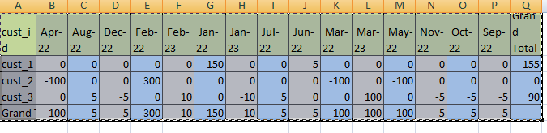

**In SQl server:**

**Syntax:**

Select * from (base query) alias

Pivot (aggregation query

For column_name in ([col_1], [col_2], [col_3] ) alias

Base Quarry, It will remove $ symbol and extract the date in asked format

Code for upper Problem:

with tx as (

select * from (

select

cust_id, format(sales_date, 'MMM-yy') as sales_date,

cast(replace(amount, '$', '') as int) as amount

from prac)

as base_t

pivot(

Aggregation query

sum(amount) for sales_date in(

[jan-01],

[jan-22],

[feb-22],

[mar-22],

[apr-22],

[may-22],

[jun-22],

[jul-22],

[aug-22],

[sep-22],

[oct-22],

[nov-22],

[dec-22]) ) as piv_t

Union with the same quarry to merge the total, here total is hard coded and the alias is given cust_id so Total will come as a value in the same column

union

select * from (

select 'Total' as

cust_id, format(sales_date, 'MMM-yy') as sales_date,

cast(replace(amount, '$', '') as int) as amount

from prac) as base_t

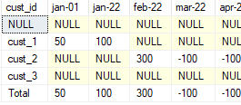

Null values are present need to treat them

pivot(

sum(amount) for sales_date in(

[jan-01],

[jan-22],

[feb-22],

[mar-22],

[apr-22],

[may-22],

[jun-22],

[jul-22],

[aug-22],

[sep-22],

[oct-22],

[nov-22],

**First cte table closed here the alias was tx**

[dec-22]) ) as piv_t),

not_null

as ( select cust_id,

isnull([jan-01], 0) as jan_01,

This code will replace the null value with 0

isnull([jan-22], 0) as jan_22,

coalesce([feb-22], 0) as feb_22,

coalesce([mar-22], 0) as mar_22,

coalesce([apr-22], 0) as apr_22,

coalesce([may-22], 0) as may_22,

coalesce([jun-22], 0) as jun_22,

coalesce([jul-22], 0) as jul_22,

coalesce([aug-22], 0) as aug_22,

coalesce([sep-22], 0) as sep_22,

coalesce([oct-22],0) oct_22,

isnull([nov-22], 0) nov_22,

coalesce([dec-22],0) as dec_22 from tx),

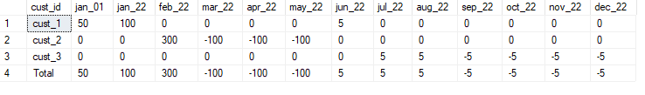

grand_total as (

select *,

(jan_01 + feb_22 + jan_22 + mar_22+ apr_22+may_22 + jun_22+jul_22+aug_22 + sep_22 + oct_22+ nov_22 + dec_22) as Grand_Total

from not_null)

This part will add the right side grand total

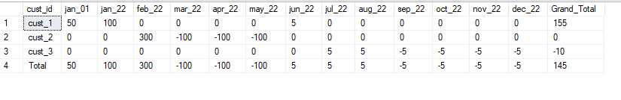

But column level aggregation we need to remove from grand_toal

select cust_id, jan_01, feb_22,

jan_22,

mar_22,

apr_22,

may_22,

jun_22,

jul_22,

aug_22,

sep_22,

oct_22,

nov_22,

dec_22, case when cust_id ='Total' then '' else

This part will stop row level aggregation. And return 0 in last of Grand_total column

(jan_01

+ feb_22 + jan_22 + mar_22 + apr_22 + may_22 +

jun_22 + jul_22 + aug_22 + sep_22 + oct_22 +

nov_22 + dec_22) end Grand_Total

from grand_total

